|  |
| --- |
|  |
| ***Charnwood Country Residence Newsletter***  **October 2021**  No photo description available.  **Much Dewchurch, Hereford HR2 8DL**  **Tel :- 01981540291**  **With Springtime fastly approaching it’s lovely to see the colours appearing in the garde**    May be an image of flower and nature May be an image of flower and nature  May be an image of natureMay be an image of flower and nature |
|  |

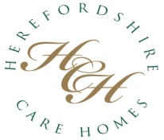

***Welcome to the next edition of our newsletter. This a great way to share up to date news and some of the meaningful ways we spend our time. We hope that you will enjoy receiving this and any feedback, or suggestions on content is always gratefully received. Email*** [***b.powell@herefordshirecarehomes.com***](mailto:b.powell@herefordshirecarehomes.com)

***Join us on our Facebook Group for day to day updates on the activities we take part in and other aspects of our daily living***

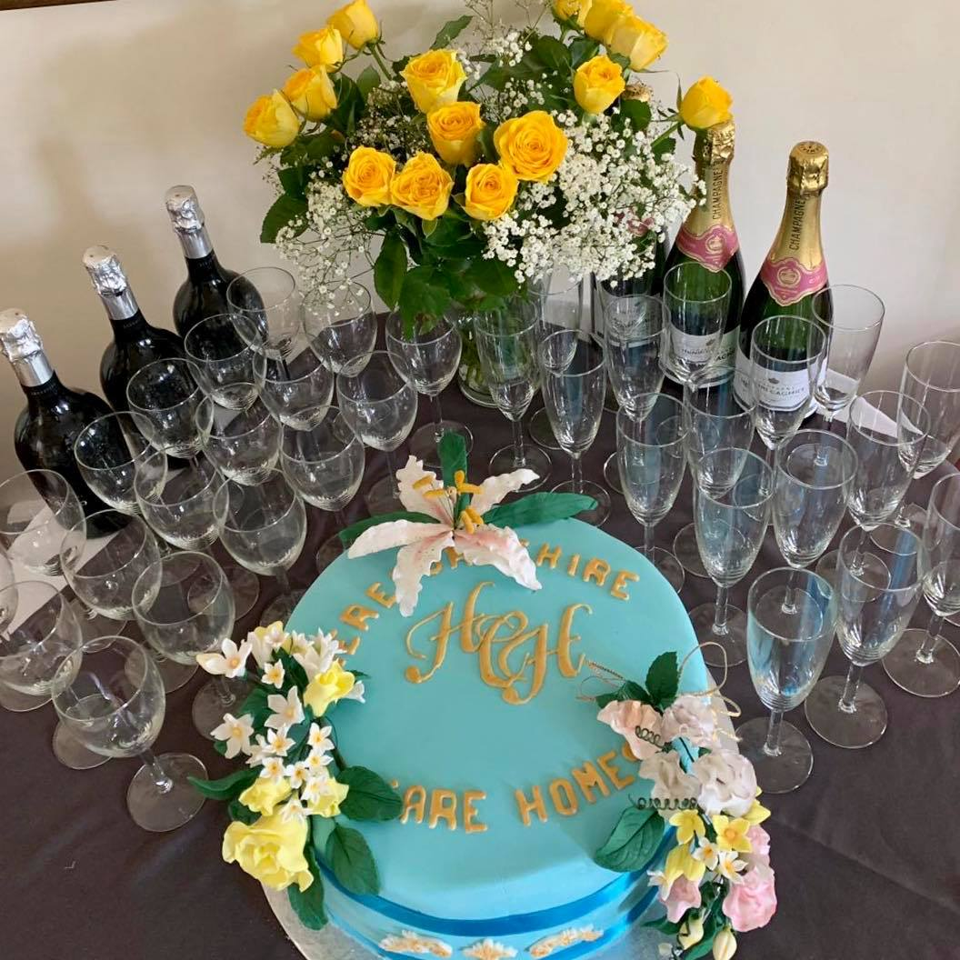

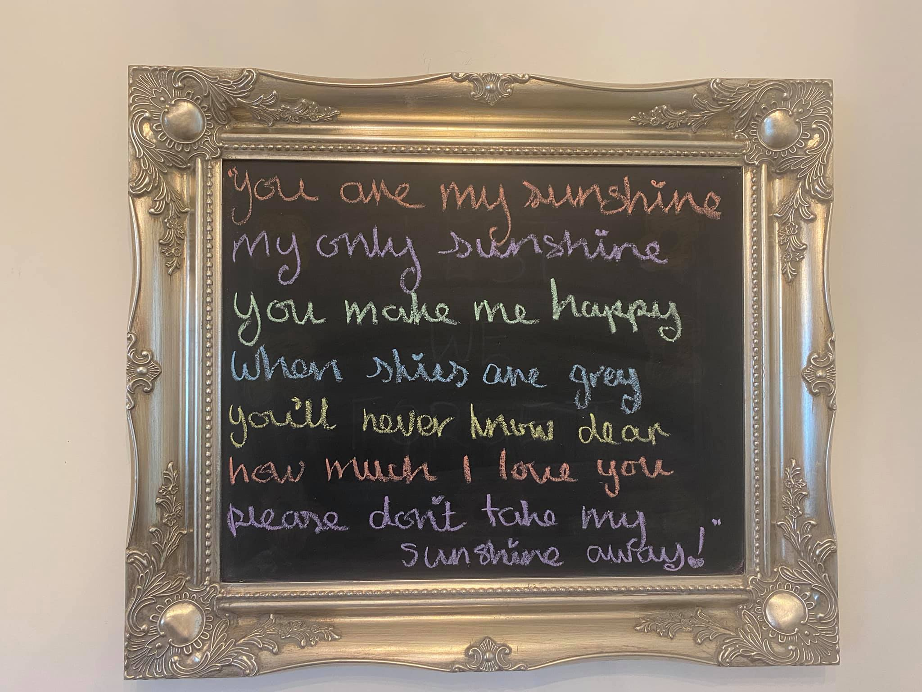

|  |
| --- |
|  |
|  |

October is the month that we celebrate our harvest festival.

We have been busy with our harvest themed arts and crafts, to decorate our home, as well as celebrating in true Charnwood style.

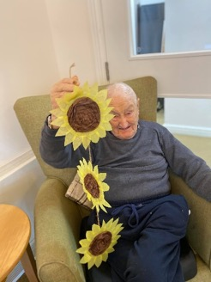 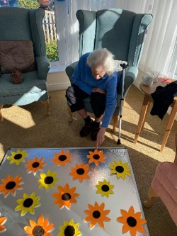 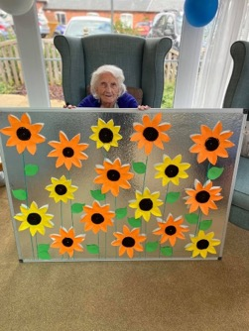 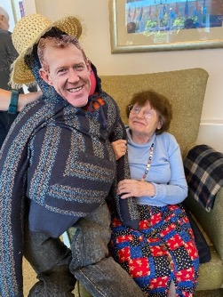

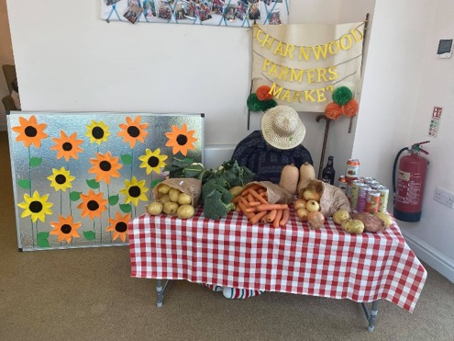 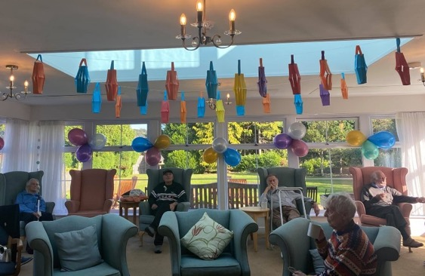

Wwe decided to create a Positivity Board for Staff & Residnts alike, as a point of interest as well as to let everyone know how valued they are!

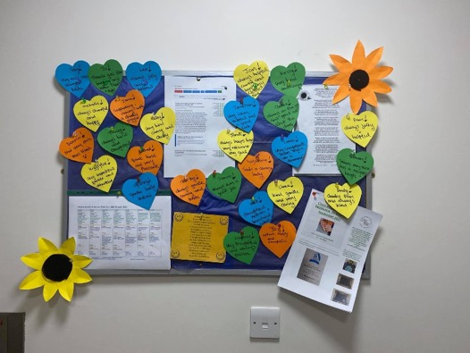 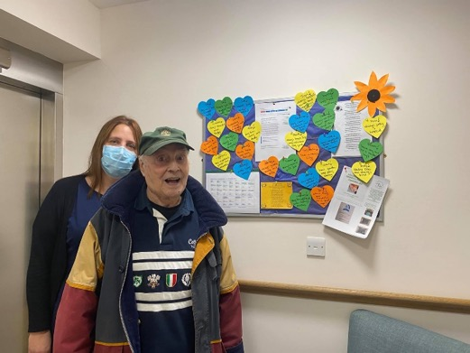

Residents and staff have had an extremely busy month, coming together to Dance For Dignity. Many of our team took time out of their own busy personal schedules to join in, which showed true dedication and commitment to their team mates and our lovely residents!

Many of our dance videos can be seen on our Facebook Page. Please take a look!

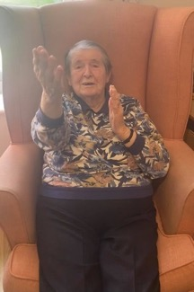 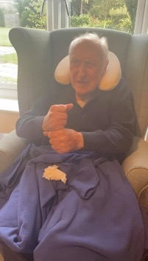 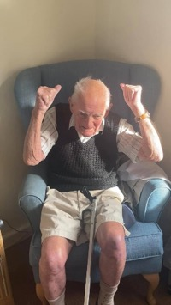 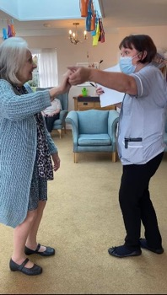 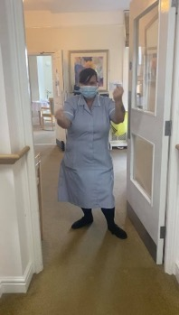

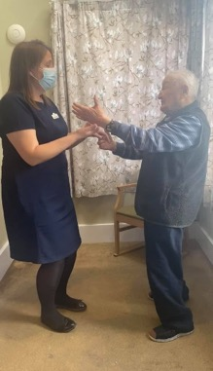 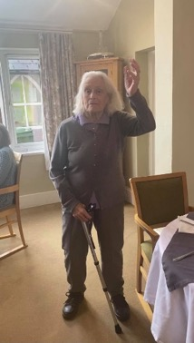 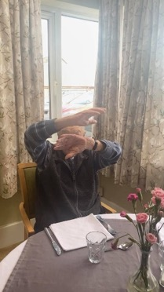 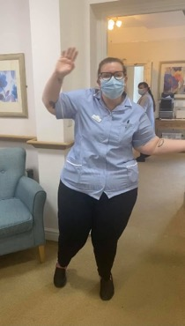 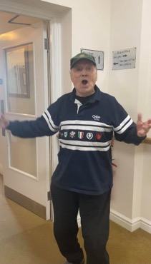

*Our team were in for a special treat as an anonymous surprise had been arranged for everyone, as a thank you for their hard work. What a wonderful gesture!*

Upcoming events

I would like to take the pleasure in introducing you all to Emily.

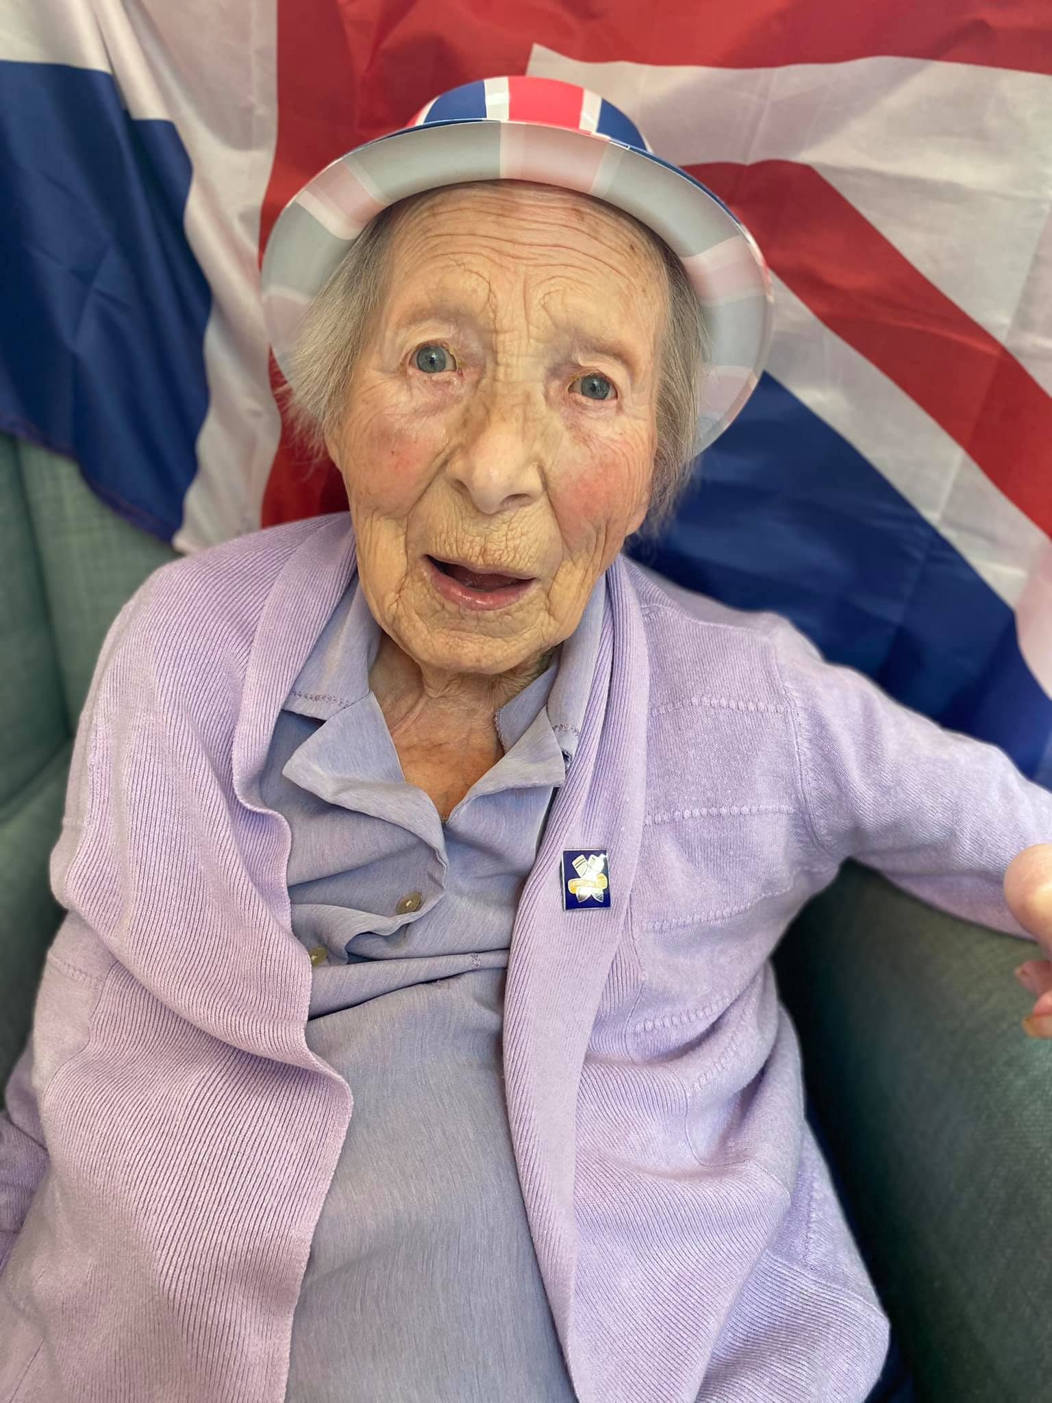

Emily has had a very special month as not only has she celebrated her birthday, but aslo was presented with a badge of honour, for her services in the munitions factory, which was situated in Llanfoist. She was one of the ladies who built radiators for Spitfire and Lancashire Bombers. Her sons brought along the award, along with an accompanying letter of thanks from our Queen. We surprised Emily with a little ceremony, including a toast, to mark the occasion. When asked how she felt about this award she replied “well I didn’t really think that much about it.” As humble as always Emily!

*Congratulations Emily, all of us here at Charnwood are extremely proud of you !* ❤️

Jill was very happy with our tomato harvest

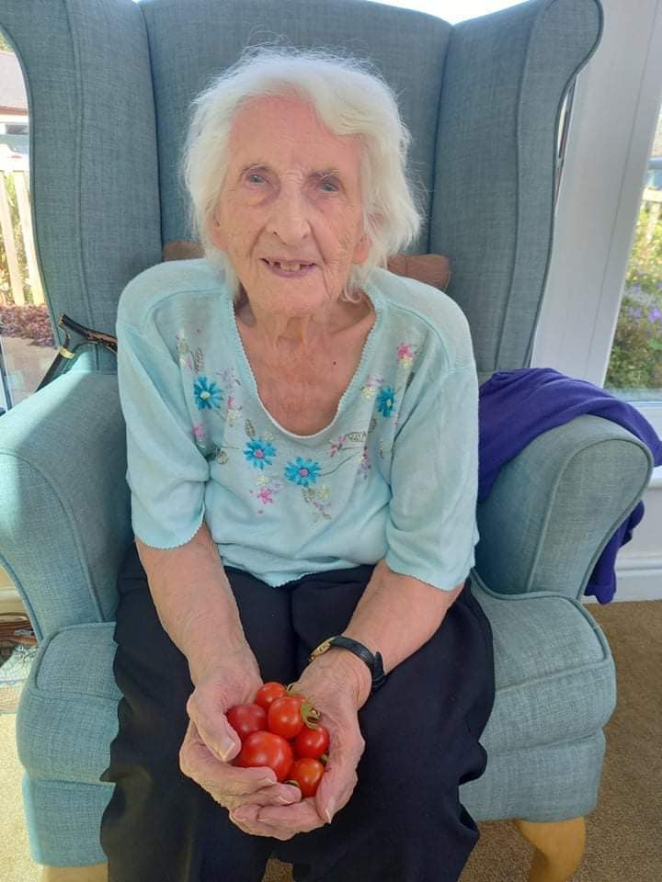

So to mark the end of our busy month we had a day filled with Halloween fun. From pumpkin and watermelon carving to dressing up. Spooky cakes and a Halloween themed facts and quizzes!....

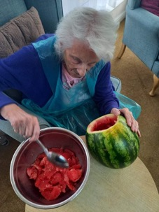 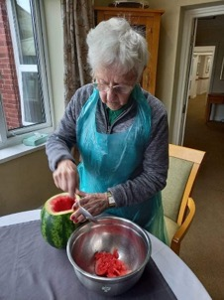 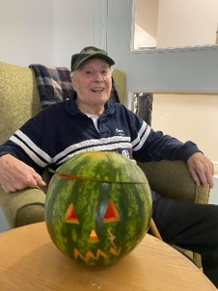 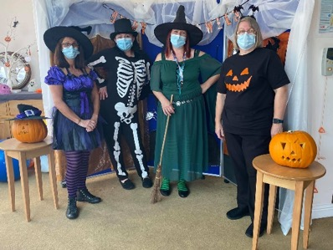

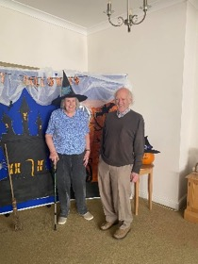 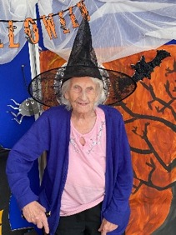 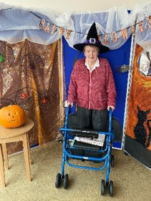 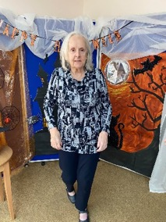 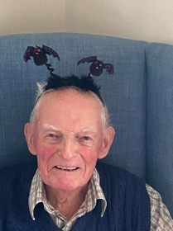

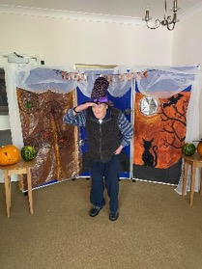 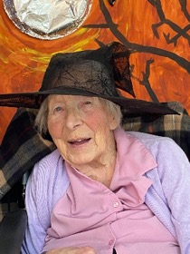 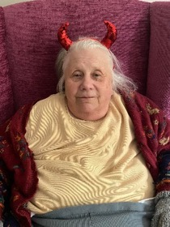 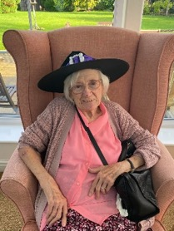 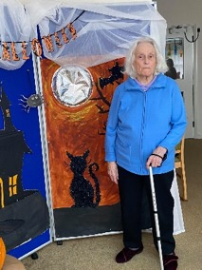

Emily & Brian celebrated their birthdays

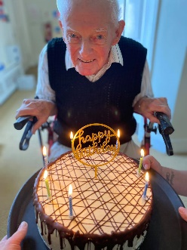 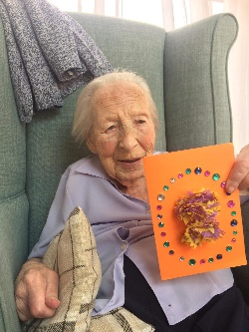

4th November Monthly Resident’s Meeting

5th November A Guy Fawkes themed presentation and quiz / virtual firework displays

10th November Remembrance Service with Rev Mark

11th November A morning of Remembrance, acknowledging the 2 minute silence

Many more arts and crafts opportunities.

Sing alongs and ball fun.

Garden games and village walks.

Weekly exercise, poetry, praise, quiz, reminiscence, flower arranging and bingo sessions.

Our next themed day/ Fine Dine Experience

|  |
| --- |
|  |
|  |
|  |

|  |
| --- |
|  |